**First in class user testing**

For the first user testing session I had the skeleton of the room with a simple fps controller and a couple of blocks to simulate the Hight that certain items in the game would be. From this I when wrote a quick questionnaire/survey to get feedback on these items and find out if the room scales were good or if they needed changing.

Some of these questions where:

what do you think of the height of the character compared to the room considering that you are a child in pre-school? (i.e you need to be bigger or smaller or some items need to be scaled)

from this question the overall responses showed that the scale of the player was about right but some of the items needed to be a bit bigger when they were added to make it seem more like you are a child (i.e the lamp). So I took a note so that when I was creating the tables and toys that that they were more representative of the scale of real world items.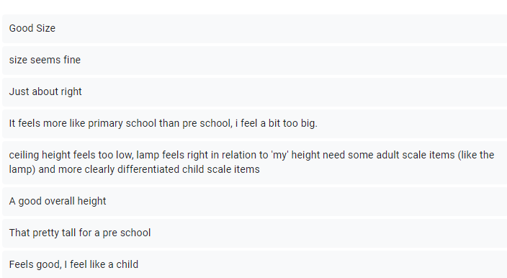

what do you think about the overall feel of the room?

The over all responses from this question meant that I had to go back into blender and have a look at the mesh of the walls because of all of the z fighting and from this I found out that there were multiple faces in the same place at certain points. I also changed the lights from an emissive to having actual lights which made the room lighter and stopped the flashing and made the room colours show brighter and less military.

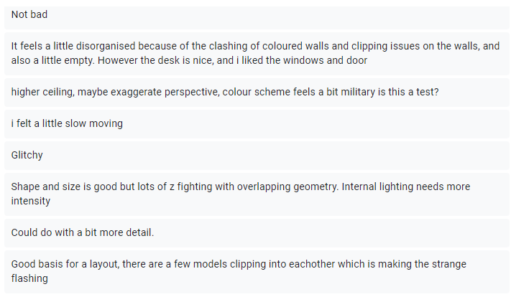

I also asked ‘do you like the current assets and do you think that there are any that definitely need to be created to make it feel more like a class room?’

And this gave me a lot of useful ideas and gave me a lot of different assets that people would want to see in a classroom to make it feel more like a classroom. This question allowed me to expand on the assets I had already created as well as create other assets such as child size tables and chairs to fill up the room and improve user experience and incorporate the overall classroom theme further into the game.

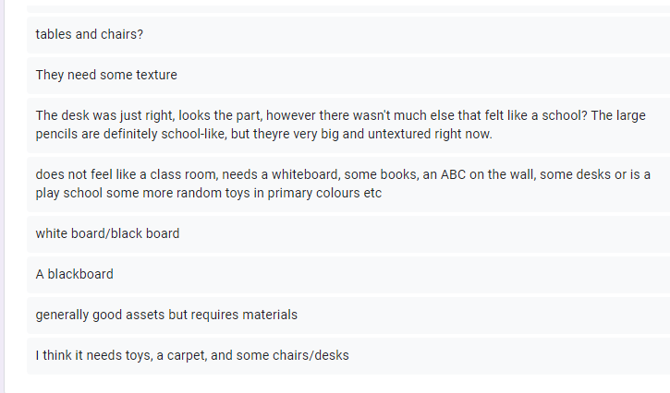

Second in class user testing:

For this usability testing I had made may of the assets that I had been given as responses in the first usability testing had also fixed the z fighting and texturing of the items I had also created a menu screen for the start of the game to try and create more of a game loop.

The questions I asked for this testing session were:

on the menu screen which of the 2 fonts do you prefer the title or the button or both?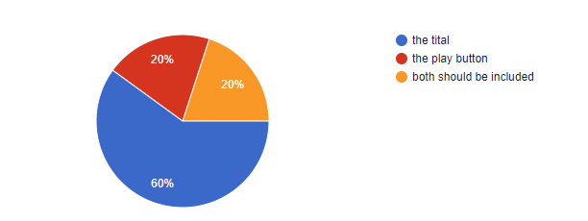

The majority of the responses that I gathered preferred the childish font of the title to the game so from this I implemented this font on the menu screen and the win/fail screens of the game. This will help to tie the beginning of the game to the end of the game and reinforce the classroom theme throughout the game.

Observations as people played:

As I watched people play the escape room I asked how the movement of the player felt and the main response was that it was good and people liked it but the mouse needed to be less sensitive. Therefore in response to this I dulled the sensitivity to slow down the player and make them more childlike. This also helped everything become more responsive and increase the time taken for the player to complete the room itself overall improving user experience.

I also asked if they needed any popups to inform the player what they needed to do or was it already self-explanatory and simple to understand.

The response to this question was that they would like some guidance to certain puzzles especially the number locate outside the classroom window. This led me to add popups for every major part of the escape room. However, this led to a secondary question: ‘was adding the popups making the room too easy to complete?’. The response I got from testers was that it wasn’t too easy but made more sense and added structure to the game. The addition of pop ups also allowed me to establish the amount of time the room should be played for (5 minutes) as that was how long testers on average took to complete the room.